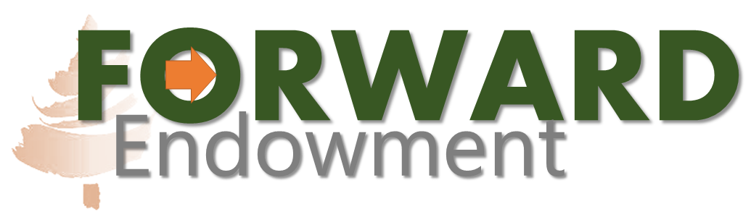
Friends of Resources Wildlife and Recreational Development
A Trust for the Future

2024 Request Form
2024 marks our 31st year of providing support to conservation projects in Manitowoc County. We have provided almost $150,000 in funding and we look forward to another strong year. Please complete the information requested. Please note that under our evaluation process the quality of the application will be considered in the evaluation process. All forms must be typed or generated from a word processor. We suggest you type your information into this document. All information must be completed for your request to be considered. This form should be typed or completed in the Word Document. Handwritten materials may not be considered.

Organization Information
Organization Name: Contact Name:

Contact Phone:
Mailing Address:
Tax Payer Id #: (Please provide both state & federal)
Project Name:

Description of Organization
Please briefly describe your organization. Provide information on the number of members, activities and any activities that are related to hunting, fishing, conservation, and education:

Requested Project Information
Project Description
Please briefly describe the project for which you are requesting funding. Also include the specific location for the project. More detailed information, such as pictures or budgets, can be attached to this form if needed.

Total Project Costs:

Amount of Funding Requested from Forward Endowment:
Please indicate a specific request for funding. Please note that the FORWARD Endowment reserves the right to fund projects for amounts less than that of the request.

Meeting the Mission of the FORWARD Endowment
The FORWARD Endowment is a trust with specific goals and intent. The following is related language from the trust document:

Intent of the Trustor and Purpose of the Trust: In creating and founding this Trust, the Trustor seeks to create a permanent fund to support activities, projects and endeavors which promote conservation, protect the natural resources, as well as the fish and game of Manitowoc County, and to enhance and promote respect for and appreciation of the same.

The Trustor recognizes that people save and protect that which they love and respect. Therefore, those activities that promote habitat and its preservation and development, hunting and fishing and similar outdoor and conservation related activities in an honorable and respectful manner are favored by the Trustor. The Trustor further recognizes that people either save or endanger the environment and that, therefore, the education of the public is of vital importance in pursuing the purposes for which the Trust was created.

Responsive to the duty to leave our natural resources, wildlife, and environment in better condition than they were found, the Trustor wishes to promote those activities which have a long-lasting positive effect.

Having read the above language of the trust, please describe how your request specifically meets these goals:

Other Information
Benefit to the Community
Please describe both who and how the project for which funds are being requested will benefit the community:

Is there an educational component to the project? ____Yes ____ No
If Yes: Please describe:

Other Funding Sources
Has this project received funding from any other organizations or private donations?
____Yes ____ No
If Yes: Please identify all sources and the amount of funding which has been provided:

Are there any matching grant programs available for this project? (Public, organization or private)
____ Yes _____ No
If Yes: Please describe:

In summary, why should the FORWARD Endowment consider funding this project?

Added Information
Is there any other information that you think would be valuable in making our decision?

This form must be submitted by December 31st, 2024, to be considered.

Grantees may be asked to display recognition signing on projects funded in full or part by the FORWARD Endowment. The FORWARD Endowment reserves the right to request additional information.

Questions and/or submissions can be sent to:
mantyfg071@gmail.com
This completed form may also be mailed to:
FORWARD Endowment
c/o Leede Research
1332 South 26th St.
Manitowoc, WI 54220

The balance of this document is For Office Use Only:

Date of Receipt:
Initials:

